Kia

**Extro Fusion Table Mount Sink Mixer with Swivel Spout**

**📝 Product Description:**

The Extro Fusion Table Mount Sink Mixer features a high-arc swivel spout and dual lever handles for effortless hot and cold water control, designed for kitchen sinks or countertop basins that demand function and flair.

**⭐ 5 Key Features (Single Line Each):**

* Dual lever handles for precise hot and cold water mixing
* Elegant high-arc swivel spout offers maximum sink coverage
* Corrosion-resistant brass body with durable chrome plating
* Ideal for countertop sinks and kitchen applications
* Smooth operation cartridge ensures drip-free usage

**📐 Product Specifications:**

* **Material:** Premium brass with chrome finish
* **Mounting Type:** Tabletop (deck mount)
* **Handle Type:** Dual lever
* **Spout Type:** Swivel spout (360° rotation)
* **Finish:** Glossy chrome
* **Inlet Size:** 15mm BSP standard
* **Cartridge Type:** Quarter-turn ceramic disc
* **Recommended Use:** Kitchen sinks, utility basins

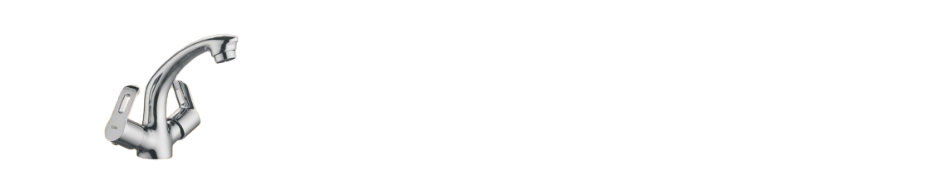

**Extro Fusion Wall Mixer with L-Bend & Shower Provision (Flat Lever)**

**📝 Product Description:**

The Extro Fusion Wall Mixer with L-Bend and shower attachment offers a smart blend of functionality and style, allowing seamless switching between overhead shower and spout through a smooth operating diverter. Ideal for modern bathrooms.

**⭐ 5 Key Features (Single Line Each):**

* Dual-handle design for separate hot and cold water control
* Smooth diverter knob for effortless shower/spout switch
* Stylish flat lever handles for a modern aesthetic
* High-performance cartridge ensures smooth, leak-free operation
* Corrosion-resistant chrome finish for long-lasting durability

**📐 Product Specifications:**

* **Material:** Brass body with chrome finish
* **Mounting Type:** Wall mounted
* **Handle Type:** Flat twin lever
* **Spout Type:** Fixed with L-Bend overhead pipe
* **Diverter:** Integrated single knob for shower/spout flow selection
* **Inlet Connection:** 15mm BSP standard
* **Finish:** Glossy chrome plating
* **Recommended Use:** Bathroom wall-mounted basin and shower setup

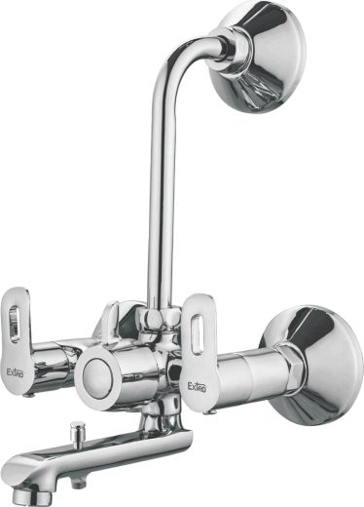

**Extro Kia Wall Mounted Basin Tap (Single Lever)**

**📝 Product Description:**

The Extro Kia Wall Mounted Basin Tap combines elegance with ease of use, featuring a sleek single lever design that ensures precise water control. A perfect choice for contemporary wash areas.

**⭐ 5 Key Features (Single Line Each):**

* Single lever design for effortless water flow and temperature control
* High-quality chrome finish for a long-lasting shine
* Wall-mounted design saves counter space and looks modern
* Smooth cartridge mechanism for drip-free performance
* Sturdy brass construction ensures durability and corrosion resistance

**📐 Product Specifications:**

* **Material:** Brass with chrome plating
* **Mounting Type:** Wall mounted
* **Handle Type:** Single flat lever
* **Finish:** Polished chrome
* **Cartridge Type:** Ceramic cartridge for smooth operation
* **Application:** Suitable for wash basins or sink areas
* **Inlet Connection:** 15mm BSP standard

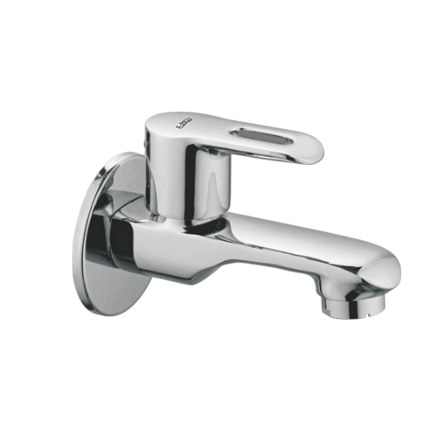

**Extro Kia Wall Mounted Bath Spout (Single Lever)**

**📝 Product Description:**

The Extro Kia Wall Mounted Bath Spout features a streamlined, minimalist design with a durable single lever, ideal for modern bathrooms seeking both function and finesse.

**⭐ 5 Key Features (Single Line Each):**

* Contemporary single lever control for smooth water flow
* Sleek wall-mounted design for space-saving installation
* Durable brass body with corrosion-resistant chrome finish
* Easy-to-clean and low-maintenance surface
* Precision-engineered cartridge for long-lasting performance

**📐 Product Specifications:**

* **Material:** Brass
* **Finish:** Polished chrome
* **Mounting Type:** Wall-mounted
* **Handle Type:** Single lever
* **Spout Length:** Standard for bath fitting (approx. 170mm–200mm)
* **Inlet Connection Size:** 15mm BSP
* **Usage:** Ideal for bathtubs and wall-mounted basin installations

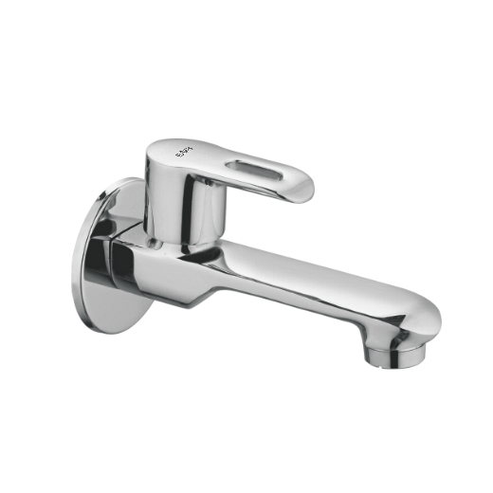

**Extro Kia Angle Valve with Lever Handle**

**📝 Product Description:**

The Extro Kia Angle Valve with lever handle is a premium, wall-mounted fitting designed for precise water control in bathrooms and kitchens, offering long-lasting durability and effortless operation.

**⭐ 5 Key Features (Single Line Each):**

* Easy-to-use single lever handle for smooth operation
* Compact and elegant design suitable for modern interiors
* Brass body with rust-resistant chrome finish
* Compatible with geysers, washing machines, and jet sprays
* Quick shut-off functionality for efficient water control

**📐 Product Specifications:**

* **Material:** Brass
* **Finish:** Chrome-plated
* **Mounting Type:** Wall-mounted
* **Handle Type:** Single lever
* **Inlet Connection Size:** 15mm BSP
* **Outlet:** Standard threaded connection for hose or pipe
* **Application:** Suitable for wash basins, toilets, geysers, and more

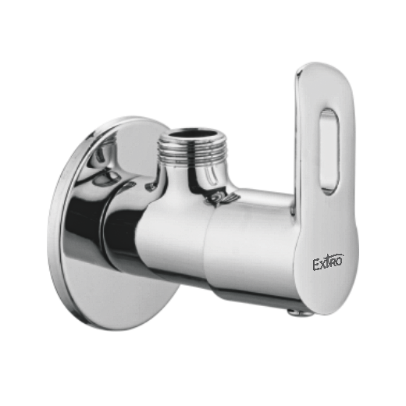

**Extro Kia Concealed Stop Cock – 15mm**

**📝 Product Description:**

The Extro Kia Concealed Stop Cock is a premium in-wall valve designed for controlling water flow in modern bathrooms and kitchens, offering both functionality and an elegant lever handle finish.

**⭐ 5 Key Features (Single Line Each):**

* Heavy-duty brass body ensures high durability
* Sleek chrome-finished lever handle for modern aesthetics
* 15mm standard inlet/outlet suitable for most plumbing setups
* Provides reliable and precise water flow control
* Corrosion-resistant materials ensure long-lasting performance

**📐 Product Specifications:**

* **Material (Body):** Brass
* **Material (Handle):** Chrome-plated metal
* **Size:** 15mm
* **Mounting Type:** Concealed in-wall installation
* **Handle Type:** Single lever
* **Finish:** Polished chrome top with raw brass body
* **Application:** Suitable for showers, basins, and concealed plumbing setups

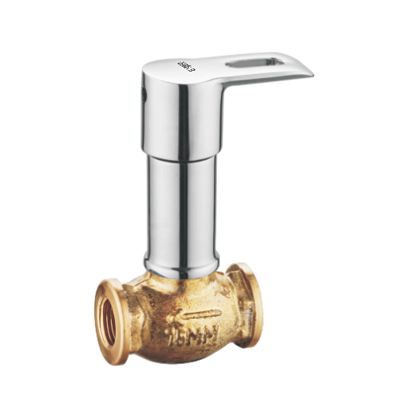

**Extro Kia Pillar Cock**

**📝 Product Description:**

The Extro Kia Pillar Cock is a modern single-lever basin tap designed for deck mounting, offering an elegant chrome finish and efficient water flow control suitable for contemporary bathrooms and wash areas.

**⭐ 5 Key Features (Single Line Each):**

* Sleek single-lever handle for effortless operation
* Corrosion-resistant chrome-plated finish for durability
* Designed for deck-mounted installation on basins
* Smooth water flow with optimal aeration
* Crafted from premium brass for long-lasting use

**📐 Product Specifications:**

* **Material:** Brass
* **Finish:** Chrome-plated
* **Installation Type:** Deck-mounted
* **Handle Type:** Single lever
* **Application:** Basin, countertop
* **Flow Type:** Aerated stream
* **Height:** Medium-rise for convenient handwashing

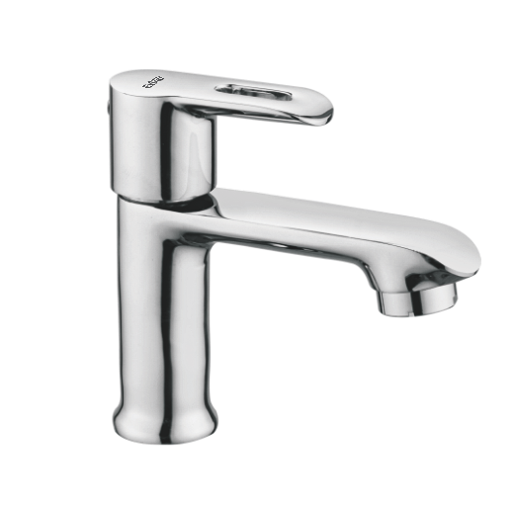

**Extro Kia 2-in-1 Bib Cock**

**📝 Product Description:**

The Extro Kia 2-in-1 Bib Cock combines dual outlet control in a sleek, modern design, ideal for managing both tap and attachment functions like a hand shower or washing machine in compact spaces.

**⭐ 5 Key Features (Single Line Each):**

* Dual outlet design for versatile water control
* Elegant single-lever handle for smooth operation
* Wall-mounted structure for space-saving installation
* High-grade chrome finish ensures long-lasting shine
* Robust brass body construction for extended durability

**📐 Product Specifications:**

* **Material:** Brass
* **Finish:** Chrome-plated
* **Mount Type:** Wall-mounted
* **Functionality:** 2-in-1 outlet (tap + attachment)
* **Handle Type:** Single lever
* **Application:** Bathrooms, utility areas
* **Flow Control:** Efficient and splash-free

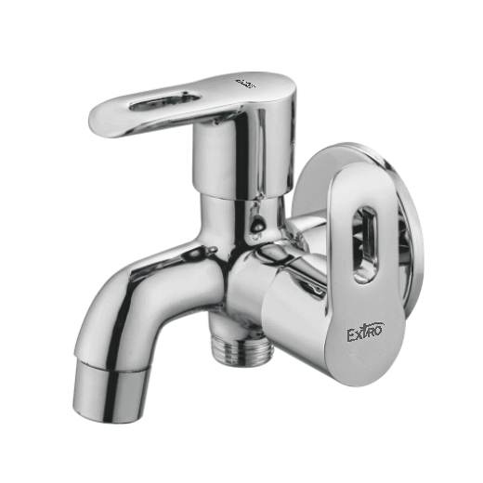

**Extro Kia Angle Cock 2-in-1**

**📝 Product Description:**

The Extro Kia Angle Cock 2-in-1 is a compact and functional wall-mounted fixture designed to control dual water outlets, combining efficiency with a sleek modern finish perfect for bathrooms and utility areas.

**⭐ 5 Key Features (Single Line Each):**

* Dual control outlet suitable for geysers and washing machines
* Sleek chrome finish provides corrosion resistance and shine
* Brass body construction ensures durability and strength
* Single-lever handle for smooth water regulation
* Wall flange included for secure and aesthetic installation

**📐 Product Specifications:**

* **Material:** Brass
* **Finish:** Chrome-plated
* **Mount Type:** Wall-mounted
* **Type:** 2-in-1 Angle Cock
* **Handle:** Single lever
* **Inlet/Outlet Threads:** Standard BSP threads
* **Application:** Bathroom fixtures, utility use

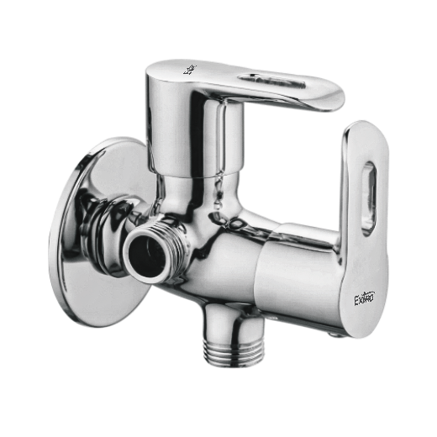

**Extro Kia Sink Cock (Wall Mounted – Swivel Spout)**

**📝 Product Description:**

The Extro Kia Sink Cock with wall-mounted swivel spout is a premium kitchen/basin fixture designed for flexibility and convenience. Its ergonomic handle, long reach, and stylish chrome finish make it ideal for modern kitchens and utility sinks.

**⭐ 5 Key Features (Single Line Each):**

* 360° swivel spout for easy and extended reach
* Smooth single-lever handle for effortless water control
* Durable brass body with high-quality chrome finish
* Wall-mounted design saves counter space
* Aerated flow for splash-free washing

**📐 Product Specifications:**

* **Material:** Brass
* **Finish:** Chrome-plated
* **Mount Type:** Wall-mounted
* **Type:** Sink Cock with Swivel Spout
* **Spout Movement:** 360° rotational
* **Handle Type:** Single lever
* **Installation Area:** Kitchen or utility sink

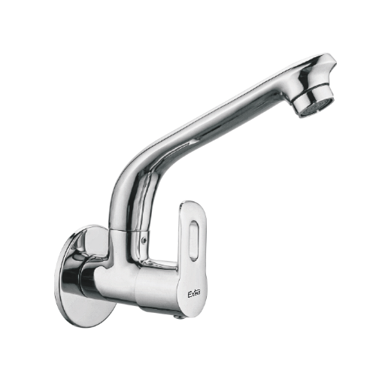

**Extro Kia Sink Mixer (Table Mounted – Swivel Spout)**

**📝 Product Description:**

The Extro Kia Table-Mounted Sink Mixer is a sleek, ergonomic solution for modern kitchens, offering a stylish chrome finish and a 360° swivel spout for added convenience in dual bowl sinks or wide washing areas.

**⭐ 5 Key Features (Single Line Each):**

* Table-mounted mixer for contemporary kitchen setups
* 360° swivel spout for full sink coverage
* Elegant and smooth single-lever control
* Chrome-plated brass for durability and shine
* Ideal for use with dual-sink configurations

**📐 Product Specifications:**

* **Material:** Brass
* **Finish:** Chrome-plated
* **Mount Type:** Table-mounted
* **Type:** Sink Mixer with Swivel Spout
* **Spout Movement:** 360° rotation
* **Handle Type:** Single lever
* **Application:** Kitchen sink or utility basin

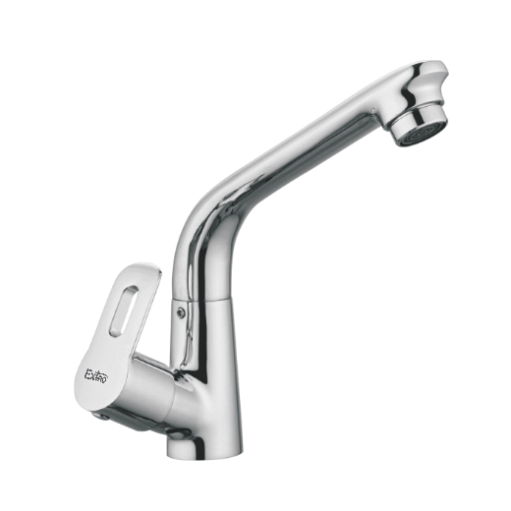

**Extro Kia Wall Mounted Sink Mixer (Swivel Spout)**

**📝 Product Description:**

The Extro Kia Wall Mounted Sink Mixer with Swivel Spout blends contemporary design and practical function, offering dual-handle water control and a 360° swivel spout to enhance flexibility and convenience in the kitchen or utility area.

**⭐ 5 Key Features (Single Line Each):**

* Wall-mounted design for efficient space utilization
* Dual-handle system for precise hot and cold mixing
* 360° swivel spout for wide-area reach and mobility
* High-quality chrome finish for lasting shine and protection
* Robust brass construction ensures durability and reliability

**📐 Product Specifications:**

* **Material:** Brass
* **Finish:** Chrome-plated
* **Mount Type:** Wall-mounted
* **Type:** Sink Mixer with Swivel Spout
* **Spout Movement:** 360° rotation
* **Handle Type:** Dual lever handles
* **Application:** Kitchen or utility sink

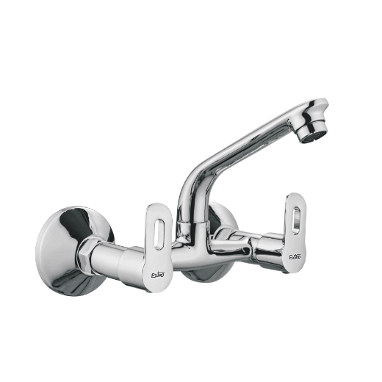

**Extro Kia Table Mount Sink Mixer (Dual Handle)**

**📝 Product Description:**

The Extro Kia Table Mount Sink Mixer with Dual Handle design delivers elegant form and functional performance, allowing smooth mixing of hot and cold water through a sleek, high-arc spout suitable for modern kitchen countertops.

**⭐ 5 Key Features (Single Line Each):**

* Table-mounted design for countertop installation
* High-arc spout for greater clearance and coverage
* Dual lever handles for precise hot and cold control
* Premium chrome finish adds elegance and corrosion resistance
* Solid brass body for long-lasting durability and leak-free performance

**📐 Product Specifications:**

* **Material:** Brass
* **Finish:** Chrome-plated
* **Mount Type:** Table-top
* **Type:** Sink Mixer with dual handle
* **Spout Design:** High-arc fixed spout
* **Handle Type:** Dual lever handles
* **Application:** Kitchen or utility sink

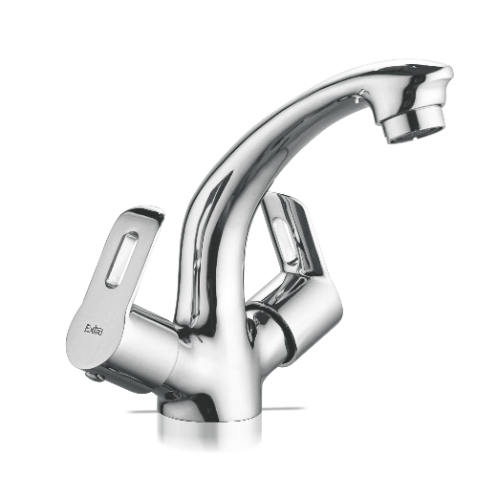

**Extro Kia Wall Mixer with Overhead & Spout (Dual Handle)**

**📝 Product Description:**

The Extro Kia Wall Mixer is a sophisticated and functional faucet that features dual control levers for hot and cold water, a center spout, and an overhead shower connection, offering complete bathing and washing versatility in your bathroom.

**⭐ 5 Key Features (Single Line Each):**

* Dual handle operation for hot and cold water control
* Integrated wall mixer with overhead and spout outlet
* Corrosion-resistant chrome finish for long-lasting shine
* Compatible with overhead showers and bathing spouts
* Sleek, ergonomic handles for ease of use and style

**📐 Product Specifications:**

* **Material:** Brass
* **Finish:** Chrome-plated
* **Mount Type:** Wall-mounted
* **Type:** Wall mixer with overhead and spout outlet
* **Number of Handles:** 2 (Dual lever)
* **Connections:** Overhead shower pipe & bottom spout
* **Application:** Bathroom (shower and bathing)

